Option A — Scratch Implementation and Evidence Guide
CORE 2: Creating a Simple Chatbot |
Purpose of this guide
This guide gives teachers and students a concrete, classroom-ready route for developing a small Scratch chatbot prototype and recording credible evidence of the development process.
It uses a topic-neutral build structure, followed by one fully worked student-style example. The example is a model, not a mandatory topic.
The guide also makes the CORE 1 principle visible through implementation, testing and evidence.

How to use this guide
- Teachers use Sections 1–3 before the lesson to check readiness, orient beginners to the Scratch workspace, and understand the minimum prototype.
- Students use Sections 4–5 during the build phase, with the teacher projecting the screenshots or distributing the student build card.
- Groups use Sections 6–7 to test the chatbot and prepare the evidence package for CORE 3.
Core design rule
Open topic, locked structure
Students may choose or adapt any safe, school-appropriate chatbot topic.
Every Scratch prototype must still include: a clear purpose, three response categories, three useful responses, one fallback response, one limitation/safety response, and one CORE 1 principle test.

1. What counts as a successful Option A prototype?
A successful Scratch chatbot does not need advanced programming, animation or artificial intelligence. It needs visible, testable logic that another group can understand and evaluate.
- one named chatbot sprite;
- one welcome message and one clear purpose statement;
- one menu question with three choices;
- three conditional response branches;
- one fallback response for unclear or unsupported input;
- one limitation/safety response;
- one visible feature linked to the group’s CORE 1 principle;
- four mini-tests, with one test labelled as the CORE 1 principle test;
- one evidence-based improvement or a justified keep-as-designed decision.
Required evidence package
Evidence item | Required? | What it shows | Suggested filename
Saved Scratch project | Yes | The working prototype and editable logic. | GroupName_CORE2_Chatbot.sb3
Complete-script screenshot | Yes | The full menu, branches, fallback and limitation logic. | GroupName_CompleteScript.png
Expected-input test | Yes | A planned category produces the intended response. | GroupName_ExpectedTest.png
Principle-test evidence | Yes | The CORE 1 principle is enacted and tested. | GroupName_PrincipleTest.png
Mini-test record | Optional separate sheet | A clean evidence record when requested. The canonical mini-test remains in the CORE 2 Student Design Worksheet Section 09. | CORE2_Mini_Test_Record_OPTIONAL.docx
CORE 3 handover card | Yes | What the peer group should test next. | CORE2_CORE3_Handover.docx

Privacy and screenshot rule
Do not include student names, email addresses or personal account details in screenshots.
Crop the browser/account bar where necessary. Screenshots should focus on the Scratch code, stage output and relevant comment.

2. Before students open Scratch
Teacher readiness checklist
- Scratch opens on the available devices and students can create or open a project.
- The teacher has tested ask and wait, answer, if / else and the equality operator.
- The Scratch workspace orientation image andtopic-neutral build screenshots are available for projection or printing.
- Students have already completed the design logic in the Student Design Worksheet.
- Each group has one CORE 1 principle translated into a concrete design requirement.
- Students know where and how to save the .sb3 file.
- A paper-based fallback is ready if the digital setup fails.
Teacher preparation and online project access
First-time preparation: allow approximately 30 minutes to build the minimum structure yourself, test the nested if/else logic, and decide how projects will be saved and shared before CORE 3.
Topic-neutral starter: https://scratch.mit.edu/projects/1332857046
Completed Recycling Helper example: https://scratch.mit.edu/projects/1332860091
What students should already have
What to add | Why it matters | Checkpoint
Chatbot name, user and purpose | Keeps the coding focused on a clear chatbot purpose.. | The group can explain what the chatbot is for in one sentence.
Three response categories | Creates a manageable menu structure. | Each category is clearly different from the others.
Three responses, fallback and limitation | Provides all content before coding starts. | Students do not invent messages while building.
CORE 1 principle and feature | Protects continuity from CORE 1. | The group can point to where users will see the principle.
Scratch workspace orientation for beginners
Before coding begins, briefly orient students to the main areas of the Scratch workspace and the block categories used in this task.
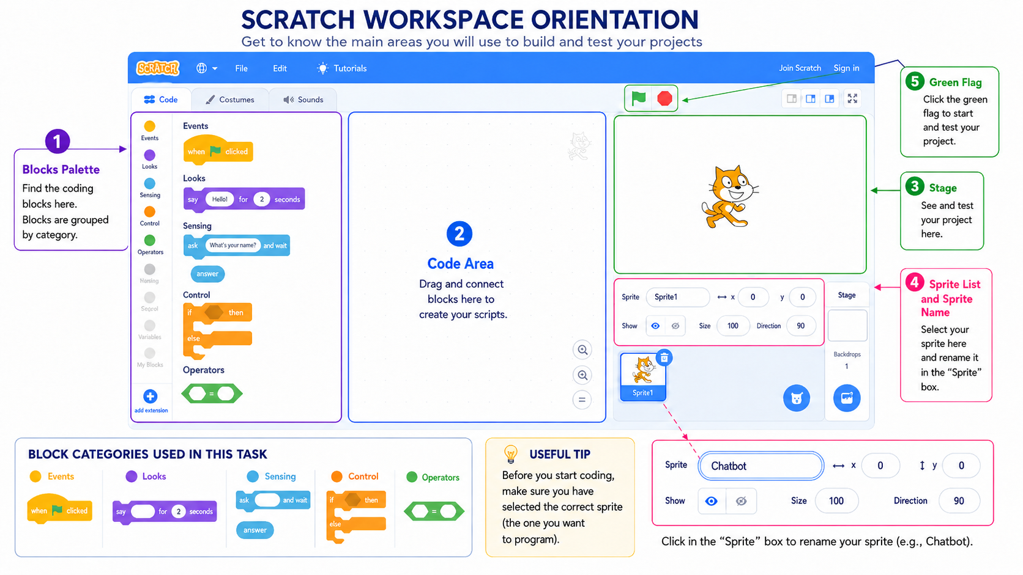
Figure 1. Scratch workspace orientation and the block categories used in this task.

Teacher move
Project Figure 1 and briefly point out the Blocks Palette, Code Area, Stage, Sprite List and Sprite Name field, and Green Flag. Show students the five block categories used in this task: Events, Looks, Sensing, Control, and Operators. Remind them to select the correct sprite and rename it “Chatbot” before coding. Tell students that backgrounds, costumes, sounds and animation are optional and should only be added after the logic works.

3. Topic-neutral Scratch build sequence
The screenshots below show the structure students should reproduce using their own approved chatbot content. Bracketed text is replaced with the group’s own content.
Step 1 — Start the chatbot and introduce its purpose
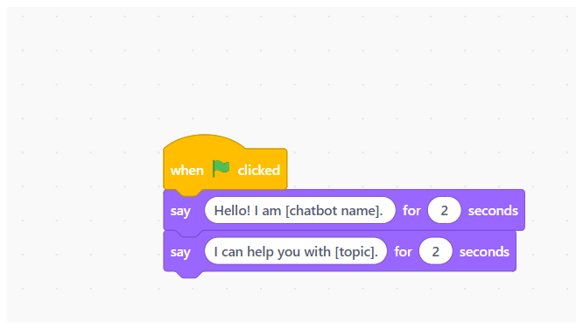
Figure 2. Start block, chatbot name and purpose message.
What to add | Why it matters | Checkpoint
Add “when green flag clicked”. Add two “say … for 2 seconds” blocks. | The chatbot starts consistently and tells the user what it can help with. | Click the green flag. The user sees the chatbot name and purpose in the correct order.

Step 2 — Ask the user to choose a category
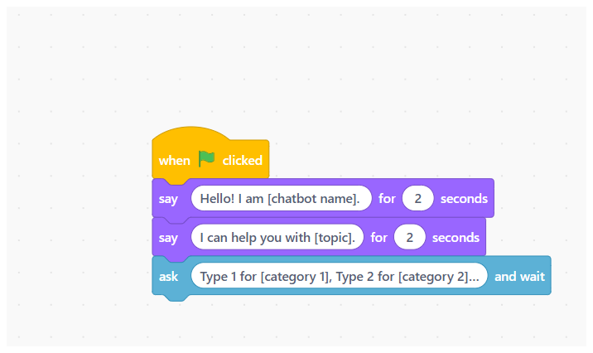
Figure 3. Menu question using ask and wait.
What to add | Why it matters | Checkpoint
Add “ask … and wait”. Use the pattern: Type 1 for [category 1], 2 for [category 2], or 3 for [category 3]. | The menu keeps the prototype small, predictable and testable. | The input box appears and all three categories are visible or clearly stated.
Caution: use the = equality operator to compare answer with 1, 2 or 3. Do not replace it with contains; number inputs may produce unintended matches.

Step 3 — Connect each choice to a response
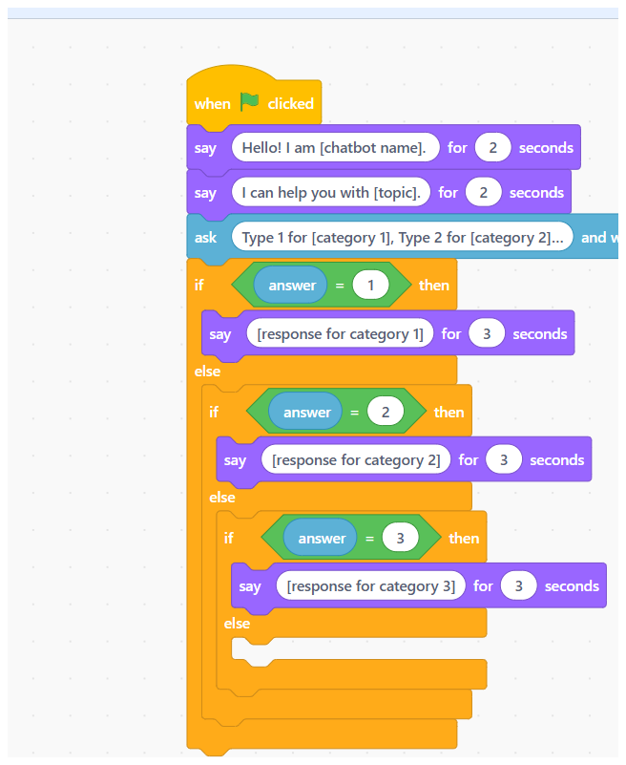
Figure 4. Three nested if / else branches.
What to add | Why it matters | Checkpoint
Use three nested “if / else” blocks. Compare answer with 1, 2 and 3. | Each user choice activates one planned response category. | Entering 1, 2 or 3 produces the correct response and no other response.

Build checkpoint before continuing
Do not add decoration or extra categories yet. First test all three planned choices. Fix the logic before adding fallback and limitation behaviour.

4. Add fallback, limitation and the CORE 1 feature
The final else branch handles any input that is not 1, 2, or 3. In the minimum starter, it contains two distinct messages shown in sequence: a recovery-oriented fallback, followed by a scope and safety limitation message.
Fallback response
The fallback helps the user recover from an unclear or mistyped input. Recommended pattern:
Fallback message pattern
I did not understand. Type 1 for [category 1], 2 for [category 2], or 3 for [category 3].

Limitation/safety response
The limitation response explains the chatbot’s scope and redirects the user when needed. Recommended pattern:
Minimum-route note: both the unclear-input test and the outside-scope test enter this final else branch. The unclear test evaluates the first recovery message; the outside-scope test evaluates the second scope/redirection message. A separate limitation branch is an optional extension, not a release requirement.
Limitation message pattern
I only help with [category 1], [category 2], and [category 3]. For other, dangerous, personal or sensitive questions, please ask a teacher or trusted adult.

Make the CORE 1 principle visible
Students add a short Scratch comment beside the exact block or response where the principle is implemented. The comment should not merely repeat the principle; it should identify the visible feature.
Scratch comment pattern
CORE 1 principle: A good chatbot should [principle].
Implemented here: [exact response, rule or behaviour where users can see it].

What to add | Why it matters | Checkpoint
Add the fallback and limitation messages in the final else branch. Add a short comment beside the implemented feature. | The chatbot does not guess, and the principle becomes observable rather than decorative. | Use an unsupported input. The chatbot recovers, explains its scope and shows the planned principle.

Minimum Scratch logic
- Green flag start.
- Two welcome/purpose messages.
- One ask-and-wait menu with three categories.
- Three if / else response branches.
- One fallback response.
- One limitation/safety response.
- One CORE 1 principle comment attached to the relevant feature.
5. Worked student example — School Recycling Helper
The following model shows how a student group can replace the topic-neutral placeholders. It is an open example, not a required project topic.
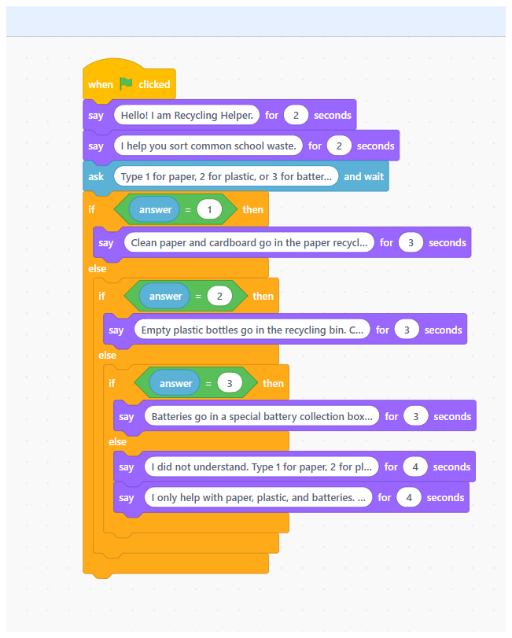
Figure 5. Complete School Recycling Helper script.
Chatbot element | Completed student content
Name | Recycling Helper
Purpose | I help you sort common school waste.
Category 1 | Paper
Response 1 | Clean paper and cardboard go in the paper recycling bin.
Category 2 | Plastic
Response 2 | Empty plastic bottles go in the recycling bin. Check your school rules.
Category 3 | Batteries
Response 3 | Batteries go in a special battery collection box. Ask a teacher.
Fallback | I did not understand. Type 1 for paper, 2 for plastic, or 3 for batteries.
Limitation | I only help with paper, plastic, and batteries. For other or dangerous items, ask a teacher.
6. Testing and evidence capture
The group completes four tests. One of the four must be labelled as the CORE 1 principle test. A fifth test is only needed if none of the four can test the principle properly.
Tests 1–2 — Two supported inputs
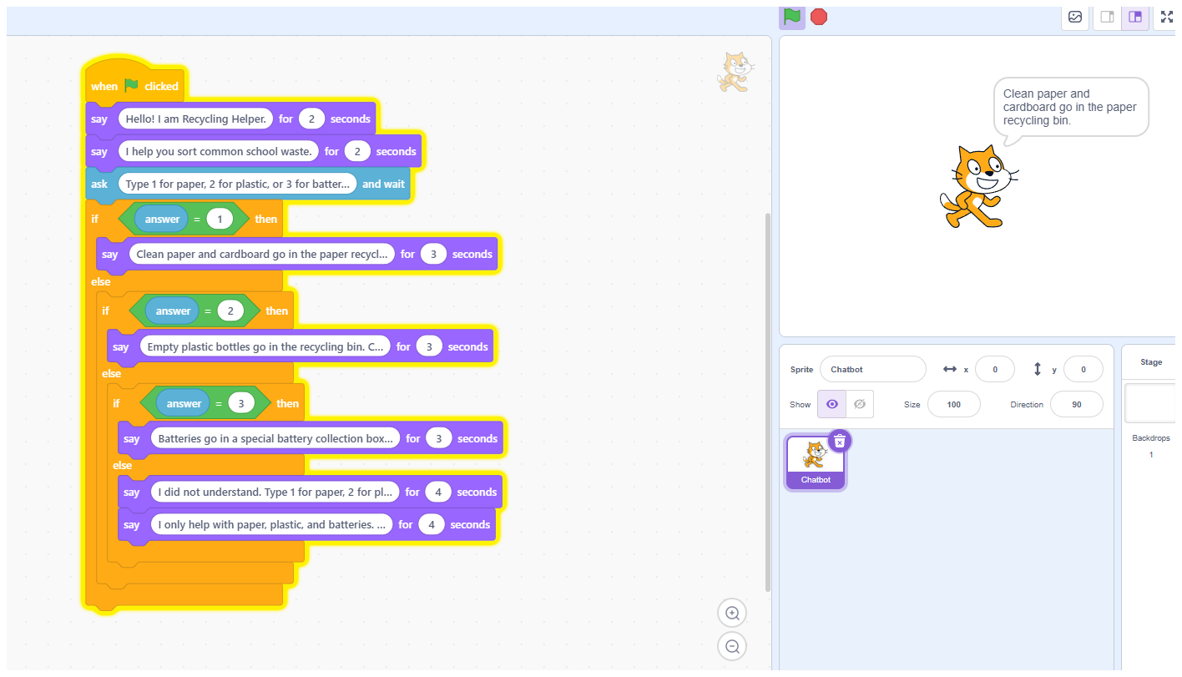
Figure 6. Supported-input test: the planned category response appears. Record a second supported choice in the CORE 2 Student Design Worksheet; a second screenshot is optional.
What to add | Why it matters | Checkpoint
Enter two different supported choices, such as 1 and 3. Capture at least one resulting response and record both tests in the CORE 2 Student Design Worksheet. | Shows that at least two planned category-response connections work. | Both responses match the selected categories and are clear to the target user.

Test 3 — Unclear input
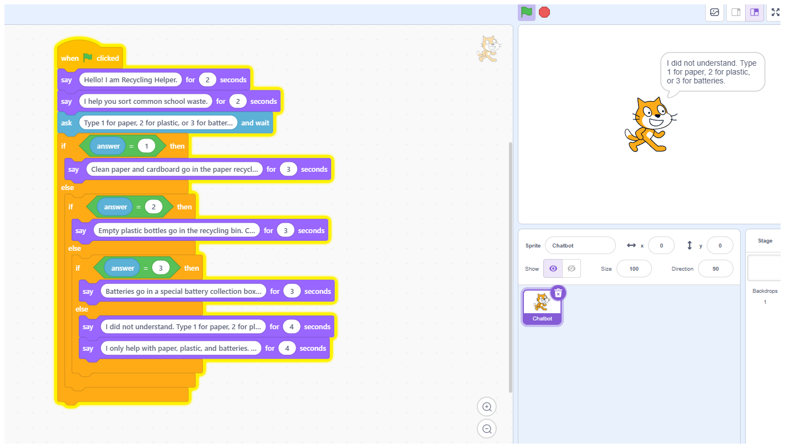
Figure 7. Fallback evidence after an unsupported input.
What to add | Why it matters | Checkpoint
Enter an unclear or mistyped input that is not 1, 2, or 3. | Checks the first message in the final else branch: the chatbot does not guess and helps the user recover. | The fallback names or restates the supported categories.

Test 4 — Outside-scope / limitation test
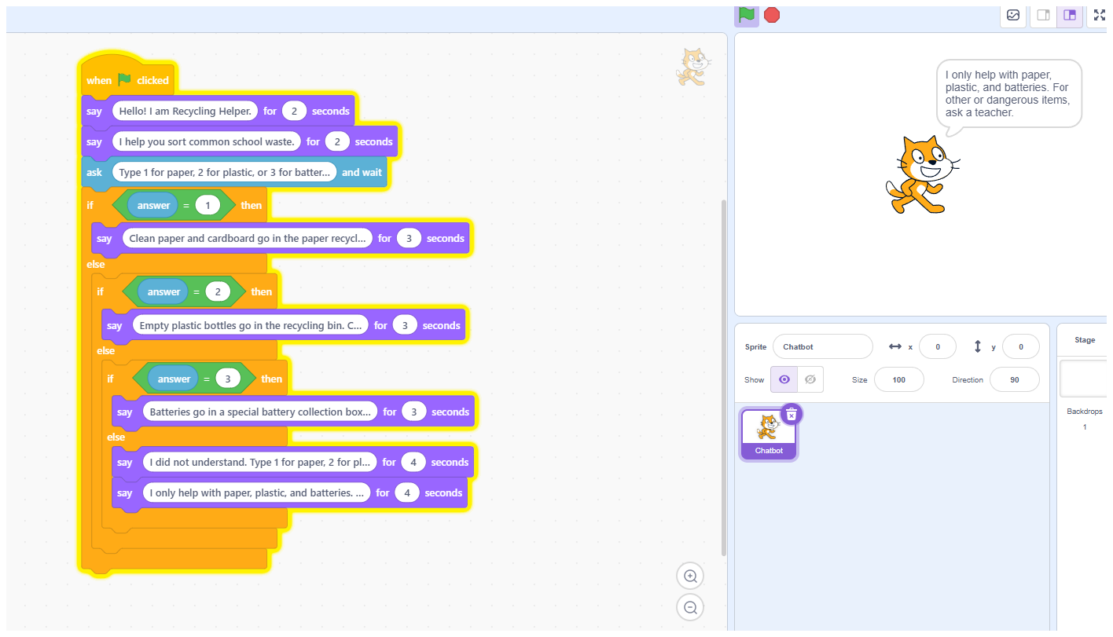
Figure 8. Limitation evidence and redirection to a teacher.
What to add | Why it matters | Checkpoint
Use an outside-topic or potentially unsafe question, such as “Can I recycle medicines?” In the minimum menu version, this also enters the final else branch. | Checks the second message in the final else branch: the chatbot explains its limits and redirects safely. | Label this row ★ CORE 1 principle test when the principle concerns limits, safety, privacy, or not guessing.
Saving and sharing plan before CORE 3
Before testing ends, save the project using a group-based filename such as GroupName_CORE2_Chatbot.sb3. If school accounts are used, confirm that the project link can be opened by the testing group. If links cannot be shared, export the .sb3 file to the teacher’s folder, school drive, or approved removable storage.
The teacher should record which group owns each project and where it is stored. CORE 3 should begin with projects already accessible; it should not spend time recovering files or rebuilding code.

7. Mandatory CORE 1 Principle Trace
The full Principle Trace is recorded once in the Student Design Worksheet. The Scratch project and screenshots provide the implementation evidence.
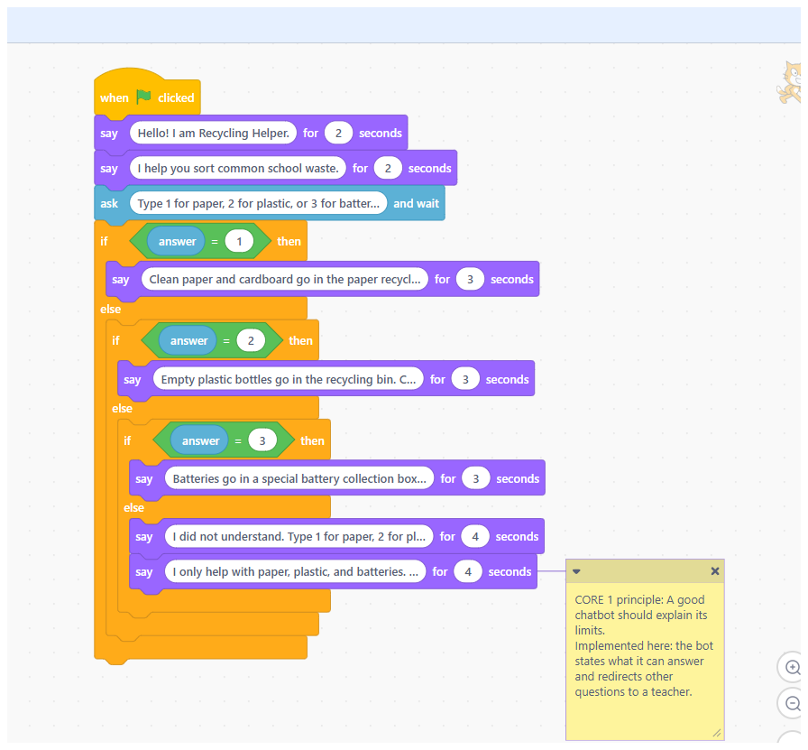
Figure 9. Scratch comment identifying the CORE 1 principle and implemented feature.
Trace stage | Worked example evidence
1. CORE 1 principle | A good chatbot should explain its limits.
2. Design requirement | The chatbot will state what it can answer and redirect unsupported questions.
3. Implemented feature | The final limitation response in the last else branch.
4. Principle-specific test | Can I recycle medicines?
5. Evidence and judgement | The chatbot stated that it only helps with paper, plastic and batteries and redirected the user to a teacher. Judgement: Yes.
6. Improvement decision | No change needed: the limitation message was clear, specific and safe.

Non-negotiable checkpoint
The prototype is not ready for CORE 3 until the group can point to the implemented feature, identify the test that checks it, and provide evidence of what happened.

8. Teacher quality check before handover
Check | Acceptable evidence | Teacher action if missing
Purpose is visible | Welcome/purpose message names the chatbot’s job. | Ask the group to rewrite the second say block.
Three categories work | Inputs 1, 2 and 3 trigger the correct response. | Check nested if / else structure and answer comparisons.
Fallback works | Unsupported input produces a recovery message. | Check the final else branch.
Limitation works | Outside-topic input produces a clear scope/safety response. | Add or rewrite the second message in the final else branch.
CORE 1 principle is visible | Comment and feature are linked; one test checks the feature. | Do not accept a principle that appears only in the worksheet.
Evidence is complete | .sb3, screenshots, test record and handover card are saved. | Use the evidence-package checklist before groups finish.
Common implementation problems
Problem | Likely cause | Teacher response
All inputs trigger the same response | The if / else blocks are not nested or the equality blocks are incomplete. | Rebuild the branch sequence from the outside in and test 1, 2 and 3 separately.
The chatbot does not respond after the menu | The ask and wait block or answer reporter is missing. | Check that the answer reporter is placed in each comparison.
Students spend time on backgrounds or sounds | They are treating the task as animation rather than chatbot design. | Use the rule: logic first, decoration later.
The principle is only written in a comment | The visible chatbot behaviour does not actually enact it. | Ask students to identify the exact response or rule that users experience.
Screenshots include personal data | The full browser/account bar was captured. | Crop the image and recapture if needed before sharing.
9. Final Option A evidence checklist
□ The Scratch project opens and the green flag starts the chatbot.
□ The chatbot states its name and purpose.
□ Inputs 1, 2 and 3 produce three different planned responses.
□ An unclear or mistyped input produces the recovery-oriented fallback message.
□ An outside-topic or unsafe question produces the scope and safety limitation message.
□ The CORE 1 principle is linked to one exact visible feature.
□ One mini-test is labelled ★ CORE 1 principle test.
□ The group recorded evidence and made one focused improvement or justified keeping the feature as designed.
□ The .sb3 file or shared project link is saved in the agreed class location, and screenshots contain no personal data.
□ The CORE 3 handover card tells the next group what to test.
Recommended teacher message
“Your chatbot does not need more features. It needs clear logic, a visible design principle, and evidence that you tested how it behaves.”

CORE 2 Option A Guide | GenSTEAMers

